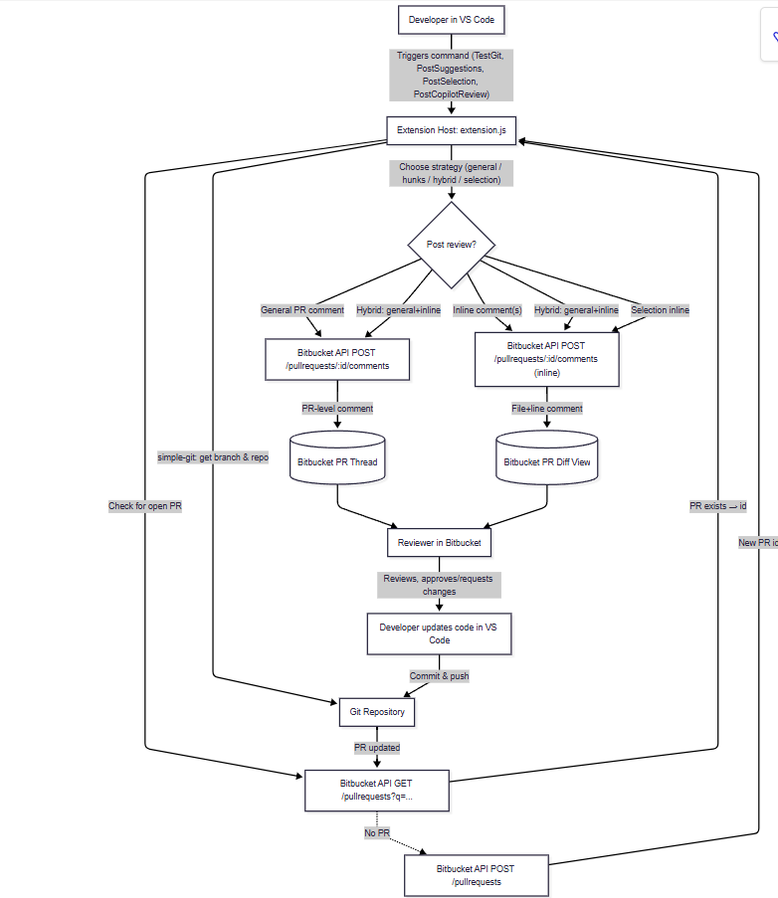

flowchart TD

    A[Developer in VS Code] -->|"Triggers command (TestGit, PostSuggestions, PostSelection, PostCopilotReview)"| B[Extension Host: extension.js]

    B -->|"simple-git: get branch & repo"| C[Git Repository]

    B -->|"Check for open PR"| D["Bitbucket API GET /pullrequests?q=..."]

    D -->|"PR exists → id"| B

    D -.->|"No PR"| E["Bitbucket API POST /pullrequests"]

    E -->|"New PR id"| B

    %% Strategy decision

    B -->|"Choose strategy (general / hunks / hybrid / selection)"| F{Post review?}

    %% General comment path

    F -->|"General PR comment"| G["Bitbucket API POST /pullrequests/:id/comments"]

    G -->|"PR-level comment"| D1[(Bitbucket PR Thread)]

    %% Inline comment path

    F -->|"Inline comment(s)"| H["Bitbucket API POST /pullrequests/:id/comments (inline)"]

    H -->|"File+line comment"| D2[(Bitbucket PR Diff View)]

    %% Hybrid path

    F -->|"Hybrid: general+inline"| G

    F -->|"Hybrid: general+inline"| H

    %% Selection path

    F -->|"Selection inline"| H

    %% Review loop

    D1 & D2 --> I[Reviewer in Bitbucket]

    I -->|"Reviews, approves/requests changes"| J[Developer updates code in VS Code]

    J -->|"Commit & push"| C

    C -->|"PR updated"| D

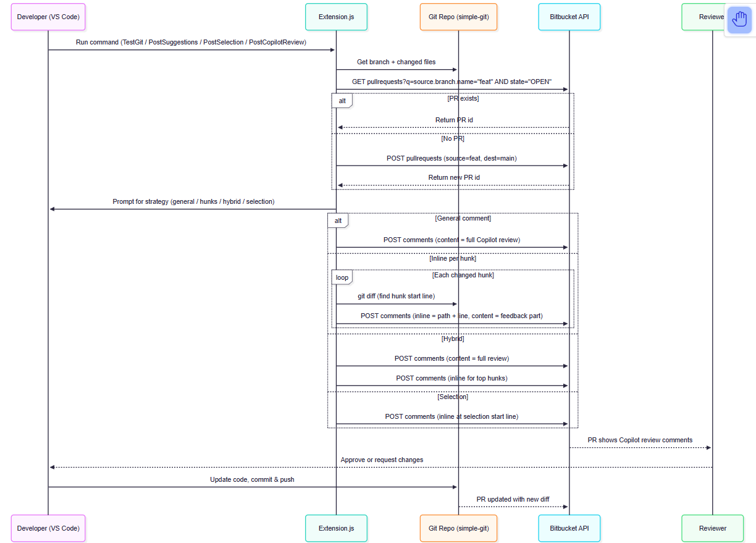

sequenceDiagram

    participant Dev as Developer (VS Code)

    participant Ext as Extension.js

    participant Git as Git Repo (simple-git)

    participant BB as Bitbucket API

    participant Rev as Reviewer

    Dev->>Ext: Run command (TestGit / PostSuggestions / PostSelection / PostCopilotReview)

    Ext->>Git: Get branch + changed files

    Ext->>BB: GET pullrequests?q=source.branch.name="feat" AND state="OPEN"

    alt PR exists

        BB-->>Ext: Return PR id

    else No PR

        Ext->>BB: POST pullrequests (source=feat, dest=main)

        BB-->>Ext: Return new PR id

    end

    Ext->>Dev: Prompt for strategy (general / hunks / hybrid / selection)

    alt General comment

        Ext->>BB: POST comments (content = full Copilot review)

    else Inline per hunk

        loop Each changed hunk

            Ext->>Git: git diff (find hunk start line)

            Ext->>BB: POST comments (inline = path + line, content = feedback part)

        end

    else Hybrid

        Ext->>BB: POST comments (content = full review)

        Ext->>BB: POST comments (inline for top hunks)

    else Selection

        Ext->>BB: POST comments (inline at selection start line)

    end

    BB-->>Rev: PR shows Copilot review comments

    Rev-->>Dev: Approve or request changes

    Dev->>Git: Update code, commit & push

    Git-->>BB: PR updated with new diff